ECE 484W

Final Project

Nicholas Barnes

01067990

Team:

Nicholas Barnes

Garland Johnson

Due: 12/11/2020

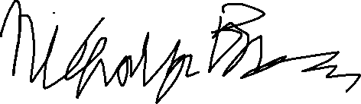

Honor Code: X______________________________

# Abstract

The purpose of this assignment is to pass camera data through the NIOS processor to the on-board monitor on the VEEK-MT2S board. The Qt GUI developed over the semester is used to transmit an image, overlay it over the video feed, and change the brightness and contrast of the camera feed using the OpenCV Library.

# Table of Contents

1. Introduction

2. Design Methodology

3. Results and Analysis

4. Alternative Design

5. Additional Considerations in Design Process

6. Broader Impact

6.1 Economic Impact

6.2 Environmental Impact

6.3 Global Impact

6.4 Societal Impact

7. Individual Contribution

8. Reference

9. Appendix

# Introduction

The objective of this project is to complete three tasks utilizing the Qt GUI and the VEEK-MT2S . The tasks are as follows:

* 1. Add an overlay image to every frame of the video stream from the on-board camera. The overlay image will be transmitted from the GUI on the computer. (Requirement #1 )
  2. Adjust brightness and contrast of the video stream from the on-board camera. The brightness and contrast values will be transmitted from the GUI on the computer. (Requirement #2)
  3. Show the result on the on-board monitor. (Requirement #3)
  4. Software Components
     1. Qt

Qt is a framework written in C++ used to extend the capabilities of C++ with features like signals and slots. The Qt version used in this assignment is 5.13.2. The Qt Creator version used is 4.13.0.

* + 1. OpenCV

“OpenCV (Open Source Computer Vision Library) is an open source computer vision and machine learning software library.” This library allows us to dynamically change the brightness and contrast of an image. The version of OpenCV used in this assignment is 4.11.

* 1. Hardware Components
     1. VEEK-MT2S

This is a Field-Programmable Gate Array that “presents a robust hardware design platform built around the Intel System-on-Chip (SoC) FPGA, which combines the latest dual-core Cortex-A9 embedded cores with industry-leading programmable logic for ultimate design flexibility.” [11] Implements a DE10-Standard with a built in touch screen interface.

* + 1. FIOS-G1100

Router used to establish communication between PC and DE-10 Standard board. Verizon service.

* + 1. Computer Specifications

These are the specifications of the computer running the Qt Software:

Model: Precision 5520

Processor: Intel Core I-7 CPU @ 2.90 GHz

RAM: 32 GB

System Type: 64 bit OS, x64-based processor.

# Design Methodology

* 1. QT GUI

The Final Assignment uses the GUI developed over the course of the semester. One section of the GUI handles TCP communication.

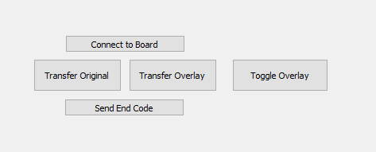

Figure 1. Board Communication Interface

Connect to Board opens a TCP socket with the server on the VEEK. Transfer Original/Overlay would send their respective images over the TCP connection, but are not used in this assignment.

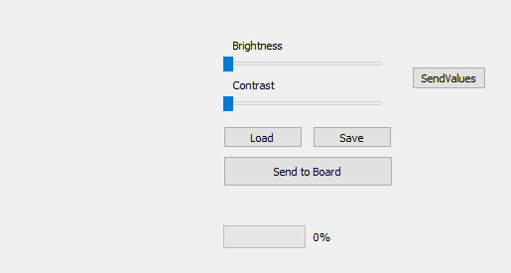

Figure 2. GUI that handles the overlay image and the brightness and contrast sliders.

“Load” loads an image to be overlaid over the camera feed. The image data is buffered using a ByteArray and a QBuffer, and sent in chunks of 1024 bytes.

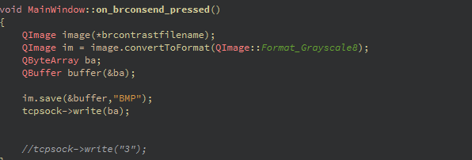

Figure 3. Writing to the TCP socket

After the image is finished sending, an end code “3” must be sent to the board by pressing the button “Send End Code.” The user can then adjust the brightness and contrast sliders and their values are sent to the board.

* 1. VEEK-MT2S C++ Server.

The C++ server on the VEEK-MT2S board is adapted from the camera_in example provided in the VEEK-MT2S CD. Before video feed can be captured, the camera must be opened. The example does this by declaring a D8MCapture object which is mapped to the memory location of the on-board camera. 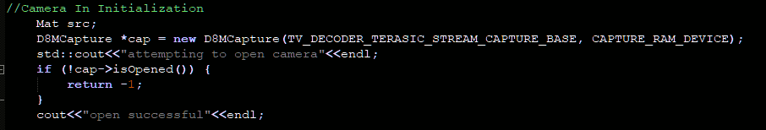

Figure 4. Opening the Camera

After a successful opening of the camera, the program sets up the TCP server. The program applies TCP properties to the socket, binds the socket to the port 8080. And starts listening for a connection. The board starts listening for image packets of 1024 bytes after accepting a connection.

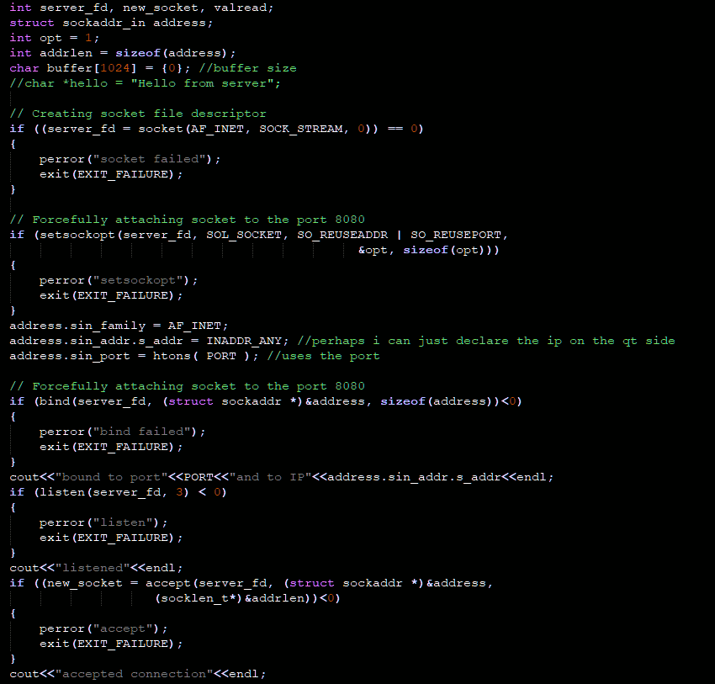

Figure 5. TCP Server Setup.

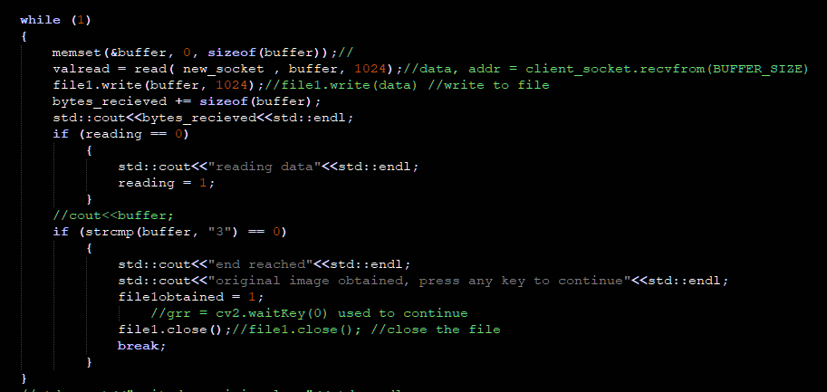

Figure 6. Accepting Image Data

After the end code is received, the image is saved to the board, resized, and converted to RGB from grayscale so that it can be properly display on the video capture.

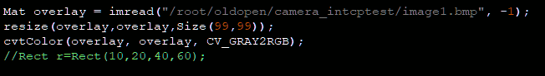

Figure 7. Adjusting the Overlay image to be overlaid onto video feed.

A loop is used to display a frame from the D8MCapture object “src.” The board then waits for brightness and contrast values from the Qt Client. The values received have 48 subtracted from them so their character data is displayed as an integer. Brightness is multiplied by 10 to make brightness changes more apparent.

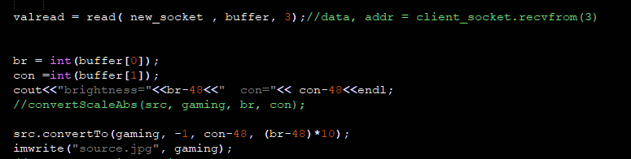

Figure 8. Brightness and Contrast Adjustment

The image received from the client is then overlaid onto the camera frame using the CopyTo() function. The final frame is then displayed on the on-board monitor.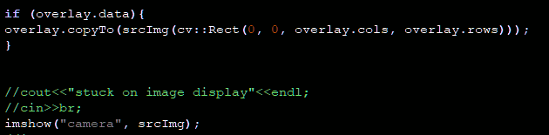

Figure 9. Overlaying Algorithm and Frame Display.

* + 1. Adjusting the brightness and contrast using OpenCV

This convertTo() function simplifies a linear transform using alpha (contrast) and beta (brightness) values. [5] The operation “g(i,j) = a * f(i,j) +B” is applied each pixel in the image through the algorithm shown below where f(i,j) is the source image and g(i,j) is the destination image:

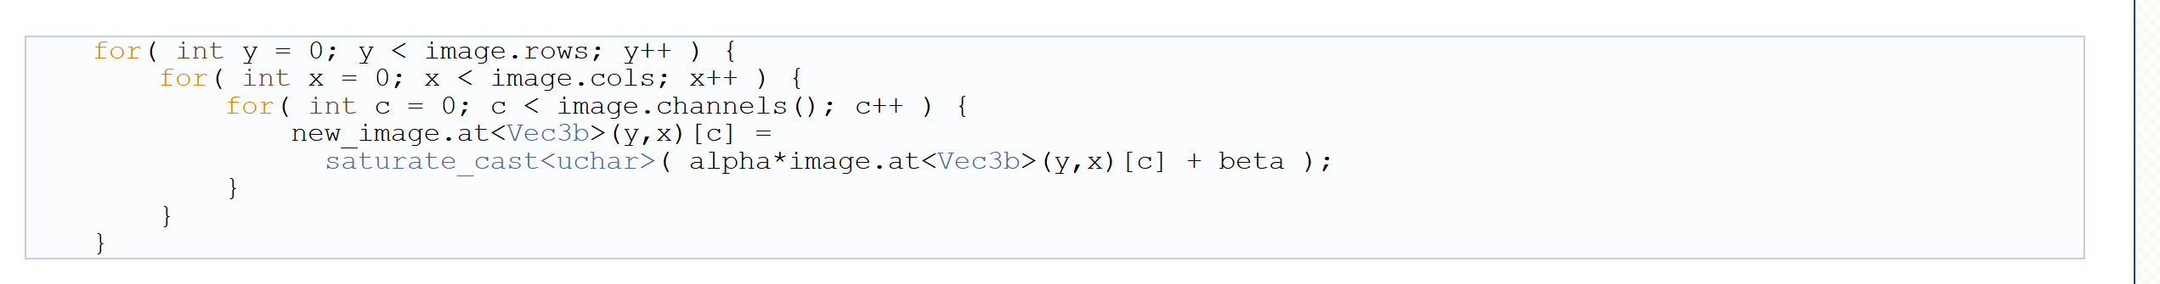 Figure 10. In-depth look at the algorithm of convertTo()

The alpha, or contrast, value is also known as gain. Beta, or brightness, is also known as bias. Adjusting these two values with the sliders will produce an image with different brightness or contrast levels.

# Analysis and Results

1. Execution

The image sent to the board must be overlaid onto the camera frame. The loop executes in this order:

* + 1. Capture Frame from Camera
    2. Adjust the Brightness and Contrast
    3. Overlay the received image.

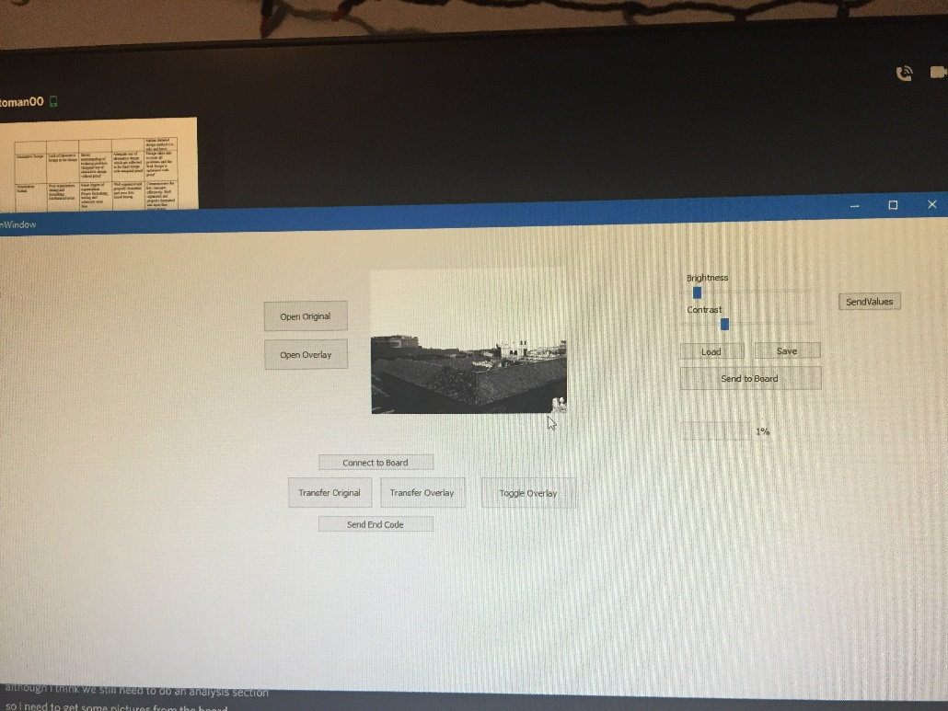

Figure 11. Normal Contrast Input

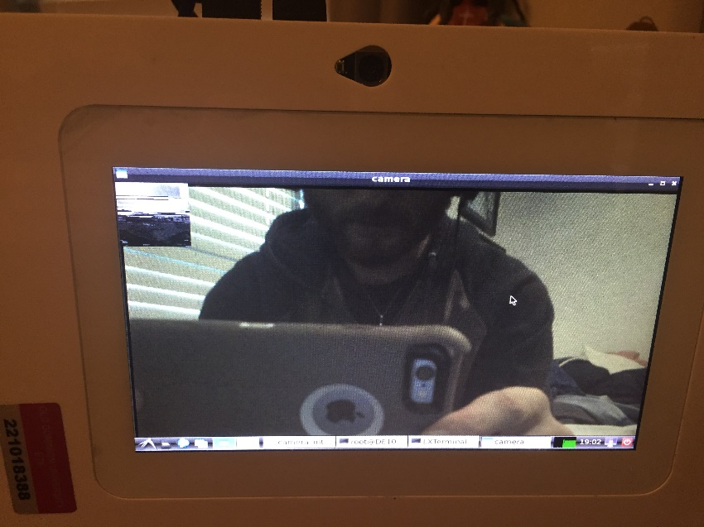

Figure 12. Normal Contrast Output.

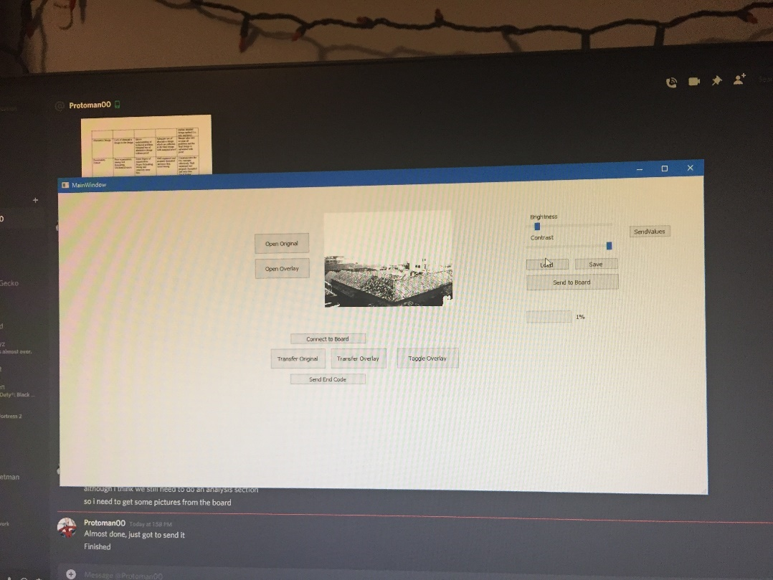

Figure 13. High Contrast Input.

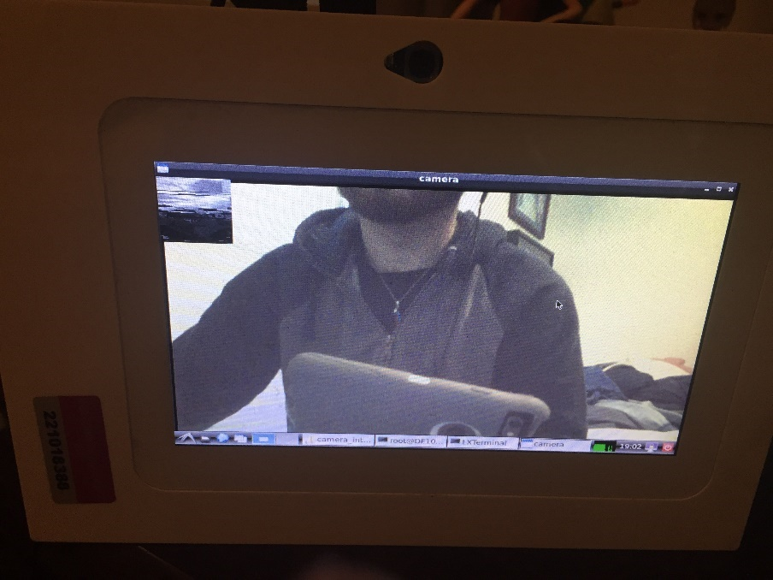

Figure 14. High Contrast Output.

B. Analysis

The images are properly overlaid onto the camera frame. However, for the camera frame to progress, another brightness/contrast value must be sent to the board. This is due to the loop waiting for a one byte packet that contains a brightness/contrast value.

The execution images are captured using an external camera. Thus, the quality of the images and the difference in results are not done proper justice.

Contrast is easy to demonstrate since its values range from 0-5. Brightness was also implemented with values 0-9. However, when demonstrating brightness with such small values it is difficult to tell the difference in a document.

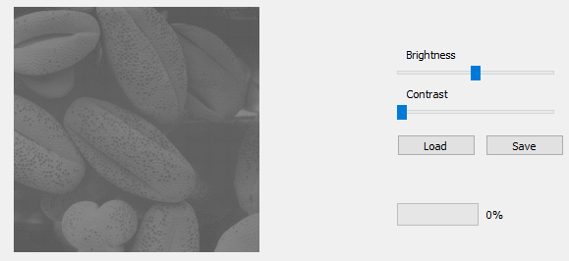

Figure 15. Image with no values

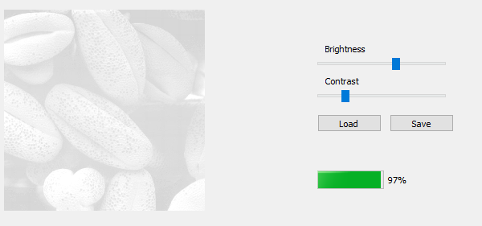

Figure 16. Image with High Brightness.*

*Note: Contrast needed to be a nonzero value for image to be properly seen.

See section 2.2.1 for more details on how the convertTo() function works.

# Alternative Design

* 1. Histogram Equalization

OpenCV has an algorithm for Histogram Equalization, equalizeHist(), which takes an image, normalizes its brightness, and increases its contrast.

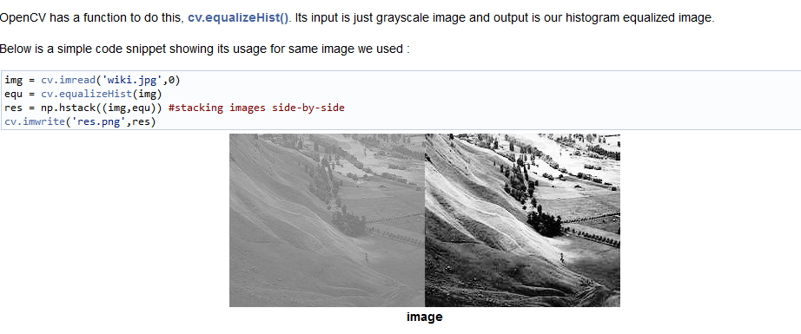

Figure 15. Image from OpenCV Python Documentation

Although this method would create a clear image from the inputted image, it does not provide a way for manually adjusting the brightness and contrast.

* 1. QT Integration on VEEK-MT2S

QT could be used to display images on the VEEK-MT2S. This would allow opening images to be automated with no further input from the user. Toggling the image would imply keeping a copy of the original image, and loading whichever image is necessary into the GUI.

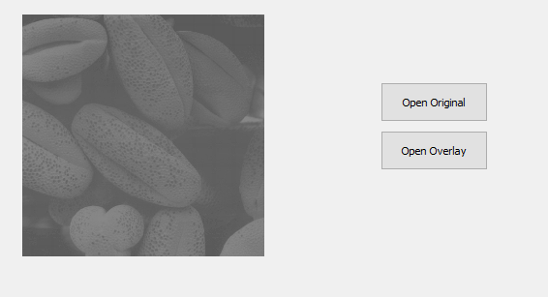 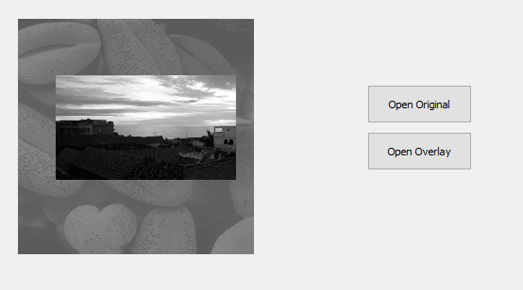

Figure 16. Before and After Toggle.

* 1. Python Integration.

We had a working TCP server, overlaying, and brightness/contrast control algorithm in python from Assignment 4. However, we were unable to get input from the camera in the Python server. Thus, we resorted to C++. If we figured out how to capture camera frames in python, we could have had more time to clean up the program, such as decreasing the time to send data to the board.

* 1. Sending dummy brightness/contrast values to the board

A possible solution to the video feed pausing when waiting for a packet is for the client to send dummy packets when the slider is not being adjusted. This would allow the video feed to continue playing while not changing the brightness and contrast of the feed.

# Additional Design Considerations

5.1 Economic Considerations:

Unlike OpenCV, Qt is not a true open source framework. Instead, those who choose to develop under Qt take a “Quid pro quo” agreement, or something for something. “In return for the value you receive from using Qt to create your application, you are expected to give back by contributing to Qt or buying Qt.[6]” Because of this, abiding loosely by the IEEE code of ethics Section 1.6 “to undertake technological tasks for others only if qualified by training or experience”, we should not pursue to release this program commercially or plan to make a profit off it. We are using the open source license for Qt for educational purposes only.

5.2 Social Considerations/Data Security:

The data we send over the network is unencrypted; anyone can see the data that we send. We must take care to not send personal information or potential security breaches across the socket. That said, the risk would be greater if the information was sent across an unsecured network. A program such as wireshark could be used to view the packets between the computer and the VEEK-MT2S.

So, when sending data over a network, we need to consider IEEE privacy standards. [IEEE Recommended Practice for Privacy Considerations for IEEE 802(R) Technologies]. Identifiers, or “A name, address, label, distinguishing index, or attribute specified in an IEEE 802® standard,” should be limited in their distribution over a network by principle of Data Minimization.

5.3 Sustainability

The code for this assignment has been adapted over many iterations. It started as a GUI to display images and adjust their brightness and contrasts. Next, it sent brightness and contrast values over a network. Finally, it sent images and brightness/contrast values and displayed it on the VEEK-MT2S. The code can be adapted further for future projects where image processing is necessary for video. For example, an autonomous vehicle that roams a dark area can have its brightness and contrast adjusted to improve visibility.

# Broader Impact

* 1. Economic Impact

Image processing is vital to the development of transportation technologies. In the dark, a self-driving car must differentiate between the road its driving on, vehicles surrounding it, and people that potentially enter the road. Perfecting this technology is key to ensuring the production of self-driving vehicles is profitable and safe [1].

Sending information across a network enables new technologies that can be sold on the market. Smart appliances can work together to provide a comfortable experience for the user [7] and will most likely get cheaper as time progresses.

* 1. Environmental Impact

Image processing is also used in wildlife monitoring. Systems such as Where’s the Bear “integrate recent advances in machine learning based image processing to automatically classify animals in images from re-mote, motion-detection camera traps [2].” Perfecting this technology could increase the efficiency of such systems, so that we can properly track how a particular species is doing in a habitat.

Networks should also be established in wildlife monitoring. Data is transmitted between sensors to provide an idea of how an ecosystem is doing, from agricultural to volcanic monitoring.[10]. It becomes a challenge to maintain sensor networks over long periods of time, but it is needed to ensure “continuous interaction with domain scientists.”

TCP can play an important role in disaster prevention, as while 5G has applications of high-quality drone video capture, it has some misalignment problems. [12] Woongsoo and co. proposed a deep learning TCP to improve stability and reliability for video capture in a disaster environment.

* 1. Global Impact

Recent events in 2020 see the West Coast of the United States burning all over. Detecting forest fires in any part of the world could be accomplished through image processing. While commercial fire sensors exist, they do not work well in open areas. Mahmoud and Ren propose an image processing algorithm that utilizes temporal variation to detect forest fires [3]. This could be effective in the United States but could also be effective in continent-wide fires such as the ones in Australia that also occurred in 2020.

In terms of networking, ensuring network security is important to maintain election fidelity. The US Department of Homeland Security, “through its Cybersecurity and Infrastructure Security Agency, provide resources to State and local election officials… to reduce cyber and physical risk to their election systems.” [9]

* 1. Societal Impact

Image processing already sees use in security and red-light cameras. However, combined with neural networks could provide a deeper identification of potential security breaches [4]. On a more basic level, increasing the brightness and contrast of an image is useful for detecting shapes in the dark, which has applications in night security.

People rely on networks to reliably transfer information from one user to another. It is also important to encrypt that information to secure users’ privacy. There is difficulty in ensuring proper encryption when many people try to send a lot of information at once. For example, environments like Twitter have millions of users sending information at once, and researchers such as Zhu propose many methods of fast, online identification methods for encryption network behaviors. [8]

# Individual Contribution

I started work on this project on November 23rd. I quickly concluded that I could not use the python server and algorithm developed for Assignment 4 due the difficulty in accessing the on-board camera. As a result, I redid the TCP server code and Image Processing algorithm in C++. I was able to get the brightness and contrast algorithm redone quickly, and on December 4th, I left it to Garland to get the overlaying algorithm done over the weekend. He did not have much success, but with the code we had he created the presentation to be recorded on the 7th. I was able to communicate with Jiajun the night of December 6th to get the overlaying algorithm done.

I did most if not all of the programming, but Garland was a real help with the presentation. I made sure to give him a chance to work on the programming, but I don’t think it’s fault that he couldn’t figure out the overlaying algorithm. I could not figure it out in the week after the brightness and contrast algorithm was complete and thought he would have better luck. It all worked out in the end, though.

# References

# [1] D. D. A. A. M. Shrey Shah, "Automated Driving CarUsing Image Processing," International Journal of Recent Trends in Engineering and Research, vol. 3, no. 4, p. 160, 2017.

# [2] N. G. C. K. R. W. Andy Rosales Elias, "Where’s The Bear? – Automating Wildlife ImageProcessing Using IoT and Edge Cloud Systems," Computer Science Department, University of California, Santa Barbara, CA, 2016.

# [3] H. R. Mubarak A. I. Mahmoud, "Forest Fire Detection Using a Rule-Based Image Processing Algorithm and Temporal Variation," Mathematical Problems in Engineering, vol. 2018, p. 8 pages, 2018.

# [4] G. R. Kotapalle and S. Kotni, "Security using image processing and deep convolutional neural networks," 2018 IEEE International Conference on Innovative Research and Development (ICIRD), Bangkok, 2018, pp. 1-6, doi: 10.1109/ICIRD.2018.8376292.

# [5] “OpenCV: Changing the contrast and brightness of an image!,” Opencv.org. [Online]. Available: https://docs.opencv.org/3.4.10/d3/dc1/tutorial_basic_linear_transform.html. [Accessed: 22-Sep-2020].

# [6] The Qt Company, “Download Qt Open Source,” Www.qt.io. [Online]. Available: https://www.qt.io/download-open-source?hsCtaTracking=9f6a2170-a938-42df-a8e2-a9f0b1d6cdce%7C6cb0de4f-9bb5-4778-ab02-bfb62735f3e5. [Accessed: 22-Sep-2020].

[7] Takenaka, Takeshi, Yamamoto, Yoshinobu, Fukuda, Ken, Kimura, Ayaka, and Ueda, Kanji. "Enhancing Products and Services Using Smart Appliance Networks." CIRP Annals 65.1 (2016): 397-400. Web.

[8] Hejun, Zhu, and Liehuang, Zhu. "Online and Automatic Identification of Encryption Network Behaviors in Big Data Environment." *Concurrency and Computation* 31.12 (2018): N/a. Web.

[9] "Cybersecurity and U.S. Campaigns and Elections: Department of Homeland Security Report on Election Security." *The Congressional Digest* 98.8 (2019): 5. Web.

[10] Dyo, Vladimir, Ellwood, Stephen, Macdonald, David, Markham, Andrew, Trigoni, Niki, Wohlers, Ricklef, Mascolo, Cecilia, Pásztor, Bence, Scellato, Salvatore, and Yousef, Kharsim. "WILDSENSING." *ACM Transactions on Sensor Networks (TOSN)* 8.4 (2012): 1-33. Web.

# 8. References (Continued)

[11] Terasic Technologies, “Terasic - SoC Platform - Cyclone - DE10-Standard,” *Com.tw*. [Online]. Available: https://www.terasic.com.tw/cgi-bin/page/archive.pl?Language=English&No=1081. [Accessed: 05-Oct-2020].

[12] Na, Woongsoo, Bae, Byungjun, Cho, Sukhee, and Kim, Nayeon. "DL-TCP: Deep Learning-Based Transmission Control Protocol for Disaster 5G MmWave Networks." IEEE Access 7 (2019): 145134-45144. Web.

# Appendix

9.1 camera_in.cpp

//CameraIN Headers

#include <opencv2/opencv.hpp>

#include <sys/time.h>

#include "D8MCapture.h"

#include "hps_0.h"

//------------------------------

//Server Headers

#include <unistd.h>

#include <stdio.h>

#include <sys/socket.h>

#include <stdlib.h>

#include <netinet/in.h>

#include <string.h>

#include <fstream>

#include <iostream>

#define PORT 8080

//

//#pragma comment (lib, "Ws2_32.lib")

//---------------------------

using namespace cv;

using namespace std;

#ifndef CAPTURE_RAM_DEVICE

#define CAPTURE_RAM_DEVICE "/dev/f2h-dma-memory"

#endif /* ifndef CAPTURE_RAM_DEVICE */

int main()

{

//Camera In Initialization

Mat src;

D8MCapture *cap = new D8MCapture(TV_DECODER_TERASIC_STREAM_CAPTURE_BASE, CAPTURE_RAM_DEVICE);

std::cout<<"attempting to open camera"<<endl;

if (!cap->isOpened()) {

return -1;

}

cout<<"open successful"<<endl;

char str[100];

static struct timeval last_time;

struct timeval current_time;

static float last_fps;

float t;

float fps;

namedWindow("camera");

//---------------------

int server_fd, new_socket, valread;

struct sockaddr_in address;

int opt = 1;

int addrlen = sizeof(address);

char buffer[1024] = {0}; //buffer size

//char *hello = "Hello from server";

// Creating socket file descriptor

if ((server_fd = socket(AF_INET, SOCK_STREAM, 0)) == 0)

{

perror("socket failed");

exit(EXIT_FAILURE);

}

// Forcefully attaching socket to the port 8080

if (setsockopt(server_fd, SOL_SOCKET, SO_REUSEADDR | SO_REUSEPORT,

&opt, sizeof(opt)))

{

perror("setsockopt");

exit(EXIT_FAILURE);

}

address.sin_family = AF_INET;

address.sin_addr.s_addr = INADDR_ANY; //perhaps i can just declare the ip on the qt side

address.sin_port = htons( PORT ); //uses the port

// Forcefully attaching socket to the port 8080

if (bind(server_fd, (struct sockaddr *)&address, sizeof(address))<0)

{

perror("bind failed");

exit(EXIT_FAILURE);

}

cout<<"bound to port"<<PORT<<"and to IP"<<address.sin_addr.s_addr<<endl;

if (listen(server_fd, 3) < 0)

{

perror("listen");

exit(EXIT_FAILURE);

}

cout<<"listened"<<endl;

if ((new_socket = accept(server_fd, (struct sockaddr *)&address,

(socklen_t*)&addrlen))<0)

{

perror("accept");

exit(EXIT_FAILURE);

}

cout<<"accepted connection"<<endl;

int reading = 0; //flag

ofstream file1;//file1 = open("image1.bmp", "wb") //getfile1

file1.open("image1.bmp",ios::binary);

int file1obtained = 0; //flag

int br = 0;

int con = 0;

int bytes_recieved = 0; //counter to keep track of all of the data

while (1)

{

memset(&buffer, 0, sizeof(buffer));//

valread = read( new_socket , buffer, 1024);//data, addr = client_socket.recvfrom(BUFFER_SIZE)

file1.write(buffer, 1024);//file1.write(data) //write to file

bytes_recieved += sizeof(buffer);

std::cout<<bytes_recieved<<std::endl;

if (reading == 0)

{

std::cout<<"reading data"<<std::endl;

reading = 1;

}

//cout<<buffer;

if (strcmp(buffer, "3") == 0)

{

std::cout<<"end reached"<<std::endl;

std::cout<<"original image obtained, press any key to continue"<<std::endl;

file1obtained = 1;

//grr = cv2.waitKey(0) used to continue

file1.close();//file1.close(); //close the file

break;

}

}

//std::cout<<"exited receiving loop"<<std::endl;

//------------------------------------

Mat overlay = imread("/root/oldopen/camera_intcptest/image1.bmp", -1);

resize(overlay,overlay,Size(99,99));

cvtColor(overlay, overlay, CV_GRAY2RGB);

//Rect r=Rect(10,20,40,60);

Mat gaming,dst;

//--CameraIN loop-----------------

while (1) {

if (!cap->read(src))

return -1;

memset(&buffer, 0, sizeof(buffer));//

/*

gettimeofday(&current_time, NULL);

t = (current_time.tv_sec - last_time.tv_sec)

+ (current_time.tv_usec - last_time.tv_usec) / 1000000.;

fps = 1. / t;

fps = last_fps * 0.8 + fps * 0.2;

last_fps = fps;

last_time = current_time;

sprintf(str, "%2.2f, %2.6f", fps, t);

putText(src, str, Point(20, 40), FONT_HERSHEY_DUPLEX, 1,

Scalar(0, 255, 0));*/

valread = read( new_socket , buffer, 3);//data, addr = client_socket.recvfrom(3)

br = int(buffer[0]);

con =int(buffer[1]);

cout<<"brightness="<<br-48<<" con="<< con-48<<endl;

//convertScaleAbs(src, gaming, br, con);

src.convertTo(gaming, -1, con-48, (br-48)*10);

imwrite("source.jpg", gaming);

//cvtColor(gaming,gaming,COLOR_GRAY2BGR);

Mat srcImg = imread("source.jpg",-1);

if (overlay.data){

overlay.copyTo(srcImg(cv::Rect(0, 0, overlay.cols, overlay.rows)));

}

//cout<<"stuck on image display"<<endl;

//cin>>br;

imshow("camera", srcImg);

//imshow("newframe", dst);

//cin>>br;

//-- bail out if escape was pressed

int c = waitKey(10);

if ((char) c == 27) {

con = 0;//break;

}

}

delete cap;

destroyAllWindows();

//------------------------------------------

return 0;

}

9.2 mainwindow.cpp

#include "mainwindow.h"

#include "ui_mainwindow.h"

#include<QFileDialog>

#include<QMessageBox>

#include<QImage>

#include <opencv2/core/core.hpp>

#include <opencv2/highgui/highgui.hpp>

#include<QtNetwork/QUdpSocket>

#include<QTcpSocket>

#include<QtNetwork/QNetworkDatagram>

#include<QBuffer>

#include<QTimer>

#include<QDebug>

#include <iostream>

using namespace cv;

MainWindow::MainWindow(QWidget *parent)

: QMainWindow(parent)

, ui(new Ui::MainWindow)

{

ui->setupUi(this);

//connect(&timer,&QTimer::timeout(),this, &on_tf_original_clicked );

}

MainWindow::~MainWindow()

{

delete ui;

}

void MainWindow::on_but_original_clicked() //When clicked, load the original image.

{

QString originalFilename=QFileDialog::getOpenFileName(

this,

tr("Open Original File"),

"",

"Bitmap (*.bmp)"

);

QImage original(originalFilename); //loads an image from the filename

ui->lbl_original->setPixmap(QPixmap::fromImage(original).scaled(250,250,Qt::KeepAspectRatio)); //set the image to the respective label

//oriTfrFilename->replace(0,99, originalFilename); //set the new filename when the image is loaded. Will not work for filenames over 100 characters

oriTfrFilename.replace(0,99, originalFilename);

}

void MainWindow::on_but_overlay_clicked() //When clicked, load the overlay image.

{

QString overlayFilename= QFileDialog::getOpenFileName(

this,

tr("Open Overlay File"),

"",

"Bitmap (*.bmp)"

);

QImage overlay(overlayFilename); //loads an image from the filename

ui->lbl_overlay->setPixmap(QPixmap::fromImage(overlay).scaled(250,250,Qt::KeepAspectRatio)); //set the image to the respective label

overTfrFilename.replace(0,99, overlayFilename);

//overTfrFilename->replace(0,99, overlayFilename); //set the new filename when the image is loaded. Will not work for filenames over 100 characters.

}

void MainWindow::on_btn_load_clicked()

{

QString brconFilename= QFileDialog::getOpenFileName(

this,

tr("Open Overlay File"),

"",

"Bitmap (*.bmp)"

);

t2imageLoad = new QImage();

brcontrastfilename = new QString();

brcontrastfilename->replace(0,99, brconFilename); //set the new filename when the image is loaded. Will not work for filenames over 100 characters.

t2imageLoad->load(brconFilename);

QImage brcon(brconFilename);

ui->lbl_t2display->setPixmap(QPixmap::fromImage(brcon).scaled(250,250,Qt::KeepAspectRatio));

}

void MainWindow::on_sldr_brightness_valueChanged(int value)

{

//When the slider is adjusted, the image's X changes by a value.

//Each time the slider is changed

//--Change the Brightness

//--Display the Image

brightness_value = value;

QString Data = "000";

// read an image

cv::Mat image = cv::imread(brcontrastfilename->toStdString(), 0);

cv::Mat image_higher_brightness;

//Change the brightness

image.convertTo(brconImage, -1, contrast_value, brightness_value);

QString cv = QString::number(contrast_value);

QString bv = QString::number(brightness_value);

Data.replace(1,1,cv);

Data.replace(2,1,bv);

tcpsock->write(Data.toStdString().c_str(), 3);

//socket->writeDatagram(packettobesent.toStdString(),host,80);

brconOut = QImage((uchar*) brconImage.data, brconImage.cols, brconImage.rows, brconImage.step, QImage::Format_Grayscale8);

ui->lbl_t2display->setPixmap(QPixmap::fromImage(brconOut).scaled(250,250,Qt::KeepAspectRatio));

}

void MainWindow::on_sldr_contrast_valueChanged(int value)

{

//When the slider is adjusted, the image's Y changes by a value.

QString Data = "000";

contrast_value = value;

// read an image

cv::Mat image = cv::imread(brcontrastfilename->toStdString(), 0);

cv::Mat image_higher_contrast;

QString cv = QString::number(contrast_value);

QString bv = QString::number(brightness_value);

Data.replace(1,1,cv);

Data.replace(2,1,bv);

//Change the brightness

image.convertTo(brconImage, -1, contrast_value, brightness_value);

tcpsock->write(Data.toStdString().c_str(), 3);

//convert to QImage

brconOut = QImage((uchar*) brconImage.data, brconImage.cols, brconImage.rows, brconImage.step, QImage::Format_Grayscale8);

//display to label

ui->lbl_t2display->setPixmap(QPixmap::fromImage(brconOut).scaled(250,250,Qt::KeepAspectRatio));

}

void MainWindow::on_but_save_clicked()

{

QString imagePath = QFileDialog::getSaveFileName(

this,

tr("Save File"),

"",

tr("Bitmap (*.bmp)" )

);

//brconOut.save(imagePath);

cv::imwrite(imagePath.toStdString(), brconImage );

//t2imageLoad->save(imagePath);

}

void MainWindow::on_pushButton_clicked()

{

//socket = new QUdpSocket;

tcpsock = new QTcpSocket;

//socket->connectToHost("192.168.1.16", 5354); //udp

tcpsock->connectToHost("192.168.1.249", 8080); //tcp

bool connectSuccess = tcpsock->waitForConnected(5000);

if(!connectSuccess)

{

//exit(-1);

qDebug() << "not Connected!";

}

// QString Data = "023";

//socket->write(Data.toStdString().c_str(), 3);

}

void MainWindow::on_tf_original_clicked()

{

QString choice = "1";

// initialize data

tcpsock->write(choice.toStdString().c_str());

QImage image(oriTfrFilename);

QImage im = image.convertToFormat(QImage::Format_Grayscale8);

QByteArray ba;

QBuffer buffer(&ba);

im.save(&buffer,"BMP");

tcpsock->write(ba);

//tcpsock->write("3");

}

void MainWindow::on_tf_overlay_clicked()

{

//function transfers contents of overTfrFilename to tcp server

QString choice = "2";

// initialize data

tcpsock->write(choice.toStdString().c_str());

QImage image(overTfrFilename);

QImage im = image.convertToFormat(QImage::Format_Grayscale8);

QByteArray ba;

QBuffer buffer(&ba);

im.save(&buffer,"BMP");

tcpsock->write(ba);

//tcpsock->write("3");

}

void MainWindow::on_endcodesend_pressed()

{

tcpsock->write("3");

}

void MainWindow::on_overlay_toggle_pressed()

{

QString flag;

if (toggle ==0)

{

QString flag = "1";

}

else

QString flag = "0";

// initialize data

tcpsock->write(flag.toStdString().c_str());

}

void MainWindow::on_brconsend_pressed()

{

QImage image(*brcontrastfilename);

QImage im = image.convertToFormat(QImage::Format_Grayscale8);

QByteArray ba;

QBuffer buffer(&ba);

im.save(&buffer,"BMP");

tcpsock->write(ba);

//tcpsock->write("3");

}

void MainWindow::on_sendvalues_toggled(bool checked)

{

}

9.3 main.cpp

#include "mainwindow.h"

#include <QApplication>

int main(int argc, char *argv[])

{

QApplication a(argc, argv);

MainWindow w;

w.show();

return a.exec();

}

9.4 mainwindow.h

#ifndef MAINWINDOW_H

#define MAINWINDOW_H

#include <QMainWindow>

//For Task 2-------------------------------

#include<QWidget>

#include<QSlider>

#include<QScrollBar>

#include<QSpinBox>

#include<QProgressBar>

#include<QVBoxLayout>

#include<QFileDialog>

#include<QMessageBox>

#include<QImage>

#include <opencv2/core/core.hpp>

#include <opencv2/highgui/highgui.hpp>

#include<QtNetwork/QUdpSocket>

#include<QtNetwork/QNetworkDatagram>

#include<QTimer>

#include <QTcpSocket>

#include<QDebug>

#include <iostream>

QT_BEGIN_NAMESPACE

namespace Ui { class MainWindow; }

QT_END_NAMESPACE

class MainWindow : public QMainWindow

{

Q_OBJECT

public:

MainWindow(QWidget *parent = nullptr);

~MainWindow();

QString oriTfrFilename;

QString overTfrFilename;

private slots:

void on_but_original_clicked();

void on_but_overlay_clicked();

void on_btn_load_clicked();

void on_but_save_clicked();

void on_sldr_brightness_valueChanged(int value);

void on_sldr_contrast_valueChanged(int value);

void on_pushButton_clicked();

void on_tf_original_clicked();

void on_tf_overlay_clicked();

void on_endcodesend_pressed();

void on_overlay_toggle_pressed();

void on_brconsend_pressed();

void on_sendvalues_toggled(bool checked);

private:

Ui::MainWindow *ui;

QPixmap t2Image;

QImage *t2imageLoad;

QString *brcontrastfilename;

cv::Mat brconImage;

int contrast_value;

int brightness_value;

QImage brconOut;

QUdpSocket *socket;

QTcpSocket *tcpsock;

QFile * FiletoSend;

QByteArray outBlock;

int toggle = 0;

//QTimer &timer;

};

#endif // MAINWINDOW_H

9.5 mainwindow.ui

<?xml version="1.0" encoding="UTF-8"?>

<ui version="4.0">

<class>MainWindow</class>

<widget class="QMainWindow" name="MainWindow">

<property name="geometry">

<rect>

<x>0</x>

<y>0</y>

<width>1254</width>

<height>595</height>

</rect>

</property>

<property name="windowTitle">

<string>MainWindow</string>

</property>

<widget class="QWidget" name="centralwidget">

<widget class="QPushButton" name="but_original">

<property name="geometry">

<rect>

<x>400</x>

<y>90</y>

<width>111</width>

<height>41</height>

</rect>

</property>

<property name="text">

<string>Open Original</string>

</property>

</widget>

<widget class="QPushButton" name="but_overlay">

<property name="geometry">

<rect>

<x>400</x>

<y>140</y>

<width>111</width>

<height>41</height>

</rect>

</property>

<property name="text">

<string>Open Overlay</string>

</property>

</widget>

<widget class="QLabel" name="lbl_original">

<property name="geometry">

<rect>

<x>30</x>

<y>10</y>

<width>311</width>

<height>271</height>

</rect>

</property>

<property name="text">

<string/>

</property>

</widget>

<widget class="QLabel" name="lbl_overlay">

<property name="geometry">

<rect>

<x>70</x>

<y>80</y>

<width>191</width>

<height>111</height>

</rect>

</property>

<property name="text">

<string/>

</property>

</widget>

<widget class="QSlider" name="sldr_brightness">

<property name="geometry">

<rect>

<x>930</x>

<y>80</y>

<width>160</width>

<height>16</height>

</rect>

</property>

<property name="minimumSize">

<size>

<width>160</width>

<height>0</height>

</size>

</property>

<property name="minimum">

<number>0</number>

</property>

<property name="maximum">

<number>9</number>

</property>

<property name="singleStep">

<number>1</number>

</property>

<property name="value">

<number>0</number>

</property>

<property name="sliderPosition">

<number>0</number>

</property>

<property name="orientation">

<enum>Qt::Horizontal</enum>

</property>

</widget>

<widget class="QSlider" name="sldr_contrast">

<property name="geometry">

<rect>

<x>930</x>

<y>120</y>

<width>160</width>

<height>16</height>

</rect>

</property>

<property name="minimum">

<number>0</number>

</property>

<property name="maximum">

<number>9</number>

</property>

<property name="singleStep">

<number>1</number>

</property>

<property name="orientation">

<enum>Qt::Horizontal</enum>

</property>

</widget>

<widget class="QLabel" name="lbl_brightness">

<property name="geometry">

<rect>

<x>940</x>

<y>60</y>

<width>61</width>

<height>16</height>

</rect>

</property>

<property name="text">

<string>Brightness</string>

</property>

</widget>

<widget class="QLabel" name="lbl_contrast">

<property name="geometry">

<rect>

<x>940</x>

<y>100</y>

<width>61</width>

<height>16</height>

</rect>

</property>

<property name="text">

<string>Contrast</string>

</property>

</widget>

<widget class="QPushButton" name="btn_load">

<property name="geometry">

<rect>

<x>930</x>

<y>150</y>

<width>80</width>

<height>22</height>

</rect>

</property>

<property name="text">

<string>Load</string>

</property>

</widget>

<widget class="QPushButton" name="but_save">

<property name="geometry">

<rect>

<x>1020</x>

<y>150</y>

<width>80</width>

<height>22</height>

</rect>

</property>

<property name="text">

<string>Save</string>

</property>

</widget>

<widget class="QLabel" name="lbl_t2display">

<property name="geometry">

<rect>

<x>540</x>

<y>10</y>

<width>361</width>

<height>271</height>

</rect>

</property>

<property name="text">

<string/>

</property>

</widget>

<widget class="QProgressBar" name="progressBar">

<property name="geometry">

<rect>

<x>930</x>

<y>250</y>

<width>118</width>

<height>23</height>

</rect>

</property>

<property name="minimum">

<number>0</number>

</property>

<property name="maximum">

<number>100</number>

</property>

<property name="value">

<number>0</number>

</property>

</widget>

<widget class="QPushButton" name="pushButton">

<property name="geometry">

<rect>

<x>470</x>

<y>290</y>

<width>151</width>

<height>22</height>

</rect>

</property>

<property name="text">

<string>Connect to Board</string>

</property>

</widget>

<widget class="QPushButton" name="tf_original">

<property name="geometry">

<rect>

<x>430</x>

<y>320</y>

<width>111</width>

<height>41</height>

</rect>

</property>

<property name="text">

<string>Transfer Original</string>

</property>

</widget>

<widget class="QPushButton" name="tf_overlay">

<property name="geometry">

<rect>

<x>550</x>

<y>320</y>

<width>111</width>

<height>41</height>

</rect>

</property>

<property name="text">

<string>Transfer Overlay</string>

</property>

</widget>

<widget class="QPushButton" name="endcodesend">

<property name="geometry">

<rect>

<x>469</x>

<y>370</y>

<width>151</width>

<height>22</height>

</rect>

</property>

<property name="text">

<string>Send End Code</string>

</property>

</widget>

<widget class="QPushButton" name="overlay_toggle">

<property name="geometry">

<rect>

<x>680</x>

<y>320</y>

<width>121</width>

<height>41</height>

</rect>

</property>

<property name="text">

<string>Toggle Overlay</string>

</property>

</widget>

<widget class="QPushButton" name="brconsend">

<property name="geometry">

<rect>

<x>930</x>

<y>180</y>

<width>171</width>

<height>31</height>

</rect>

</property>

<property name="text">

<string>Send to Board</string>

</property>

</widget>

<widget class="QPushButton" name="sendvalues">

<property name="geometry">

<rect>

<x>1120</x>

<y>90</y>

<width>75</width>

<height>23</height>

</rect>

</property>

<property name="text">

<string>SendValues</string>

</property>

</widget>

</widget>

<widget class="QMenuBar" name="menubar">

<property name="geometry">

<rect>

<x>0</x>

<y>0</y>

<width>1254</width>

<height>21</height>

</rect>

</property>

</widget>

<widget class="QStatusBar" name="statusbar"/>

</widget>

<resources/>

<connections>

<connection>

<sender>sldr_brightness</sender>

<signal>valueChanged(int)</signal>

<receiver>progressBar</receiver>

<slot>setValue(int)</slot>

<hints>

<hint type="sourcelabel">

<x>883</x>

<y>80</y>

</hint>

<hint type="destinationlabel">

<x>890</x>

<y>227</y>

</hint>

</hints>

</connection>

</connections>

</ui>

9.6 D8MCapture.cpp

#include <stdint.h>

#include <unistd.h>

#include <fcntl.h>

#include <sys/mman.h>

#include <socal/hps.h>

#include <opencv2/opencv.hpp>

#include <sys/ioctl.h>

#include "D8MCapture.h"

using namespace cv;

#define HW_REGS_BASE (ALT_STM_OFST)

#define HW_REGS_SPAN (0x04000000)

#define HW_REGS_MASK (HW_REGS_SPAN - 1)

#define BUFF_SPAN (800 * 480 * 4 * 2)

#define H2F_MASK (H2F_SPAN - 1)

#define IORD(base, index) (*(((uint32_t *)base)+index))

#define IOWR(base, index, data) (*(((uint32_t *)base)+index) = data)

#define REG_CONTROL 0

#define REG_STATUS 1

#define REG_MEM_ADDR 2

#define REG_FRAME_DIM 3

#define REG_DETECTED_FRAME_DIM 4

// bit mask for CONTROL

#define CONTROL_CAPTURE_BIT 0x01

#define CONTROL_DUMMY_DATA_BIT 0x02

#define CONTROL_AUTO_FRAME_DIM_BIT 0x04

// bit mask for STATUS

#define STATUS_DONE_BIT 0x01

#define STATUS_FIFO_FULL_BIT 0x02

#define STATUS_INVALID_FRAME_BIT 0x04

cv::D8MCapture::D8MCapture()

{

opened = false;

frame_index = 0;

}

cv::D8MCapture::D8MCapture(uint32_t capture_base, const char *capture_ram_device)

{

opened = false;

frame_index = 0;

open(capture_base, capture_ram_device);

}

cv::D8MCapture::~D8MCapture()

{

release();

}

bool cv::D8MCapture::retrieve(OutputArray image, int flag)

{

bool bDone = false;

int width, height;

uint32_t value;

value = IORD(capture_controller, REG_DETECTED_FRAME_DIM);

width = (value >> 16) & 0xFFFF;

height = value & 0xFFFF;

//printf("width:%d, height:%d\r\n", width, height);

bDone = true;

image.create(480, 800, CV_8UC4);

Mat src = image.getMat();

if (frame_index == 0)

memcpy(src.ptr(), capture_sdram1, width * height * 4);

else

memcpy(src.ptr(), capture_sdram2, width * height * 4);

return bDone;

}

bool cv::D8MCapture::wait_done(int timeout_s)

{

bool bDone = false;

int i = timeout_s * 1000 * 1000 / 100;

uint32_t status;

while (!bDone && i >= 0) {

status = IORD(capture_controller, REG_STATUS);

if ((status & STATUS_DONE_BIT) == STATUS_DONE_BIT) {

//printf("done, status=%xh\r\n", status);

bDone = true;

}

usleep(100);

i--;

}

capture_status = status;

return bDone;

}

bool cv::D8MCapture::grab()

{

bool bDone = false;

bDone = wait_done(1);

if (frame_index == 0) {

IOWR(capture_controller, REG_MEM_ADDR, capture_sdram_base);

frame_index = 1;

} else {

IOWR(capture_controller, REG_MEM_ADDR,

capture_sdram_base + (800 * 480 * 4));

frame_index = 0;

}

start_capture();

return bDone;

}

void cv::D8MCapture::start_capture()

{

uint32_t Command;

Command = 0;

Command |= CONTROL_CAPTURE_BIT | CONTROL_AUTO_FRAME_DIM_BIT;

IOWR(capture_controller, REG_CONTROL, Command);

Command &= ~CONTROL_CAPTURE_BIT;

IOWR(capture_controller, REG_CONTROL, Command);

Command |= CONTROL_CAPTURE_BIT;

IOWR(capture_controller, REG_CONTROL, Command);

}

bool cv::D8MCapture::read(OutputArray image)

{

bool bSuccess = true;

if (bSuccess == true)

bSuccess = grab();

if (bSuccess == true)

bSuccess = retrieve(image);

return bSuccess;

}

bool cv::D8MCapture::isOpened()

{

return opened;

}

bool cv::D8MCapture::open(uint32_t capture_base, const char *capture_ram_device)

{

int fd;

fd = ::open(capture_ram_device,O_RDWR);

if (fd < 0) {

printf("ERROR: could not open %s...\n", capture_ram_device);

return false;

}

if (ioctl(fd, 0, &capture_sdram_base) != 0) {

printf("ERROR: could not read buffer phy...\n");

close(fd);

return false;

}

close(fd);

if ((mem_fd = ::open("/dev/mem", (O_RDWR | O_SYNC))) == -1) {

printf("ERROR: could not open \"/dev/mem\"...\n");

return (1);

}

h2f_lw_virtual_base = mmap(NULL, HW_REGS_SPAN, (PROT_READ | PROT_WRITE),

MAP_SHARED, mem_fd, HW_REGS_BASE);

if (h2f_lw_virtual_base == MAP_FAILED) {

printf("ERROR: mmap() failed...\n");

close(mem_fd);

return false;

}

capture_sdram1 = (uint8_t *) mmap(NULL, BUFF_SPAN, (PROT_READ | PROT_WRITE),

MAP_SHARED, mem_fd, capture_sdram_base);

if (capture_sdram1 == MAP_FAILED) {

printf("ERROR: axi mmap() failed...\n");

close(mem_fd);

return false;

}

capture_sdram2 = capture_sdram1 + (800 * 480 * 4);

capture_controller = (uint32_t*) ((uint8_t*) h2f_lw_virtual_base

+ ((ALT_LWFPGASLVS_OFST + capture_base) & HW_REGS_MASK));

IOWR(capture_controller, REG_MEM_ADDR, capture_sdram_base);

start_capture();

opened = true;

return true;

}

void cv::D8MCapture::release()

{

if (munmap(capture_sdram1, BUFF_SPAN) != 0) {

printf("ERROR: munmap() failed...\n");

}

if (munmap(h2f_lw_virtual_base, HW_REGS_SPAN) != 0) {

printf("ERROR: munmap() fggailed...\n");

}

close(mem_fd);

opened = false;

}

9.7 D8MCapture.h

#ifndef D8MCAPTURE_H_

#define D8MCAPTURE_H_

#include <stdint.h>

#include <opencv2/opencv.hpp>

namespace cv {

class D8MCapture {

public:

D8MCapture();

D8MCapture(uint32_t capture_base, const char *capture_ram_device);

bool grab();

bool isOpened();

bool open(uint32_t capture_base, const char *capture_ram_device);

bool read(OutputArray image);

bool retrieve(OutputArray image, int flag = 0);

void release();

virtual ~D8MCapture();

//D8MCapture & operator>>(Mat &image);

private:

bool opened;

int mem_fd;

void *h2f_lw_virtual_base;

uint32_t *capture_controller = NULL;

int frame_index;

uint8_t *capture_sdram1 = NULL;

uint8_t *capture_sdram2 = NULL;

uint32_t capture_sdram_base;

uint32_t capture_status;

bool wait_done(int timeout_s);

void start_capture();

};

} /* namespace cv */

#endif /* D8MCAPTURE_H_ */

9.8 hps.h

#ifndef _ALTERA_HPS_0_H_

#define _ALTERA_HPS_0_H_

/*

* This file was automatically generated by the swinfo2header utility.

*

* Created from SOPC Builder system 'soc_system' in

* file './soc_system.sopcinfo'.

*/

/*

* This file contains macros for module 'hps_0' and devices

* connected to the following masters:

* h2f_axi_master

* h2f_lw_axi_master

*

* Do not include this header file and another header file created for a

* different module or master group at the same time.

* Doing so may result in duplicate macro names.

* Instead, use the system header file which has macros with unique names.

*/

/*

* Macros for device 'sysid_qsys', class 'altera_avalon_sysid_qsys'

* The macros are prefixed with 'SYSID_QSYS_'.

* The prefix is the slave descriptor.

*/

#define SYSID_QSYS_COMPONENT_TYPE altera_avalon_sysid_qsys

#define SYSID_QSYS_COMPONENT_NAME sysid_qsys

#define SYSID_QSYS_BASE 0x1000

#define SYSID_QSYS_SPAN 8

#define SYSID_QSYS_END 0x1007

#define SYSID_QSYS_ID 2899645186

#define SYSID_QSYS_TIMESTAMP 1492071627

/*

* Macros for device 'jtag_uart', class 'altera_avalon_jtag_uart'

* The macros are prefixed with 'JTAG_UART_'.

* The prefix is the slave descriptor.

*/

#define JTAG_UART_COMPONENT_TYPE altera_avalon_jtag_uart

#define JTAG_UART_COMPONENT_NAME jtag_uart

#define JTAG_UART_BASE 0x2000

#define JTAG_UART_SPAN 8

#define JTAG_UART_END 0x2007

#define JTAG_UART_READ_DEPTH 512

#define JTAG_UART_READ_THRESHOLD 8

#define JTAG_UART_WRITE_DEPTH 512

#define JTAG_UART_WRITE_THRESHOLD 8

/*

* Macros for device 'ledr', class 'altera_avalon_pio'

* The macros are prefixed with 'LEDR_'.

* The prefix is the slave descriptor.

*/

#define LEDR_COMPONENT_TYPE altera_avalon_pio

#define LEDR_COMPONENT_NAME ledr

#define LEDR_BASE 0x3000

#define LEDR_SPAN 16

#define LEDR_END 0x300f

#define LEDR_BIT_CLEARING_EDGE_REGISTER 0

#define LEDR_BIT_MODIFYING_OUTPUT_REGISTER 0

#define LEDR_CAPTURE 0

#define LEDR_DATA_WIDTH 10

#define LEDR_DO_TEST_BENCH_WIRING 0

#define LEDR_DRIVEN_SIM_VALUE 0

#define LEDR_EDGE_TYPE NONE

#define LEDR_FREQ 50000000

#define LEDR_HAS_IN 0

#define LEDR_HAS_OUT 1

#define LEDR_HAS_TRI 0

#define LEDR_IRQ_TYPE NONE

#define LEDR_RESET_VALUE 0

/*

* Macros for device 'sw', class 'altera_avalon_pio'

* The macros are prefixed with 'SW_'.

* The prefix is the slave descriptor.

*/

#define SW_COMPONENT_TYPE altera_avalon_pio

#define SW_COMPONENT_NAME sw

#define SW_BASE 0x4000

#define SW_SPAN 16

#define SW_END 0x400f

#define SW_IRQ 1

#define SW_BIT_CLEARING_EDGE_REGISTER 0

#define SW_BIT_MODIFYING_OUTPUT_REGISTER 0

#define SW_CAPTURE 1

#define SW_DATA_WIDTH 10

#define SW_DO_TEST_BENCH_WIRING 0

#define SW_DRIVEN_SIM_VALUE 0

#define SW_EDGE_TYPE ANY

#define SW_FREQ 50000000

#define SW_HAS_IN 1

#define SW_HAS_OUT 0

#define SW_HAS_TRI 0

#define SW_IRQ_TYPE EDGE

#define SW_RESET_VALUE 0

/*

* Macros for device 'key', class 'altera_avalon_pio'

* The macros are prefixed with 'KEY_'.

* The prefix is the slave descriptor.

*/

#define KEY_COMPONENT_TYPE altera_avalon_pio

#define KEY_COMPONENT_NAME key

#define KEY_BASE 0x5000

#define KEY_SPAN 16

#define KEY_END 0x500f

#define KEY_IRQ 0

#define KEY_BIT_CLEARING_EDGE_REGISTER 0

#define KEY_BIT_MODIFYING_OUTPUT_REGISTER 0

#define KEY_CAPTURE 1

#define KEY_DATA_WIDTH 4

#define KEY_DO_TEST_BENCH_WIRING 0

#define KEY_DRIVEN_SIM_VALUE 0

#define KEY_EDGE_TYPE ANY

#define KEY_FREQ 50000000

#define KEY_HAS_IN 1

#define KEY_HAS_OUT 0

#define KEY_HAS_TRI 0

#define KEY_IRQ_TYPE EDGE

#define KEY_RESET_VALUE 0

/*

* Macros for device 'alt_vip_vfr_vga', class 'alt_vip_vfr'

* The macros are prefixed with 'ALT_VIP_VFR_VGA_'.

* The prefix is the slave descriptor.

*/

#define ALT_VIP_VFR_VGA_COMPONENT_TYPE alt_vip_vfr

#define ALT_VIP_VFR_VGA_COMPONENT_NAME alt_vip_vfr_vga

#define ALT_VIP_VFR_VGA_BASE 0x31000

#define ALT_VIP_VFR_VGA_SPAN 128

#define ALT_VIP_VFR_VGA_END 0x3107f

/*

* Macros for device 'alt_vip_cl_mixer_0', class 'alt_vip_cl_mixer'

* The macros are prefixed with 'ALT_VIP_CL_MIXER_0_'.

* The prefix is the slave descriptor.

*/

#define ALT_VIP_CL_MIXER_0_COMPONENT_TYPE alt_vip_cl_mixer

#define ALT_VIP_CL_MIXER_0_COMPONENT_NAME alt_vip_cl_mixer_0

#define ALT_VIP_CL_MIXER_0_BASE 0x32000

#define ALT_VIP_CL_MIXER_0_SPAN 512

#define ALT_VIP_CL_MIXER_0_END 0x321ff

/*

* Macros for device 'seg7', class 'TERASIC_SEG7'

* The macros are prefixed with 'SEG7_'.

* The prefix is the slave descriptor.

*/

#define SEG7_COMPONENT_TYPE TERASIC_SEG7

#define SEG7_COMPONENT_NAME seg7

#define SEG7_BASE 0x33000

#define SEG7_SPAN 32

#define SEG7_END 0x3301f

/*

* Macros for device 'ir_rx', class 'TERASIC_IR_RX_FIFO'

* The macros are prefixed with 'IR_RX_'.

* The prefix is the slave descriptor.

*/

#define IR_RX_COMPONENT_TYPE TERASIC_IR_RX_FIFO

#define IR_RX_COMPONENT_NAME ir_rx

#define IR_RX_BASE 0x34000

#define IR_RX_SPAN 8

#define IR_RX_END 0x34007

/*

* Macros for device 'spi', class 'altera_avalon_spi'

* The macros are prefixed with 'SPI_'.

* The prefix is the slave descriptor.

*/

#define SPI_COMPONENT_TYPE altera_avalon_spi

#define SPI_COMPONENT_NAME spi

#define SPI_BASE 0x35000

#define SPI_SPAN 32

#define SPI_END 0x3501f

#define SPI_IRQ 2

#define SPI_CLOCKMULT 1

#define SPI_CLOCKPHASE 0

#define SPI_CLOCKPOLARITY 1

#define SPI_CLOCKUNITS "Hz"

#define SPI_DATABITS 16

#define SPI_DATAWIDTH 16

#define SPI_DELAYMULT "1.0E-9"

#define SPI_DELAYUNITS "ns"

#define SPI_EXTRADELAY 0

#define SPI_INSERT_SYNC 0

#define SPI_ISMASTER 1

#define SPI_LSBFIRST 0

#define SPI_NUMSLAVES 1

#define SPI_PREFIX "spi_"

#define SPI_SYNC_REG_DEPTH 2

#define SPI_TARGETCLOCK 20000000

#define SPI_TARGETSSDELAY "0.0"

/*

* Macros for device 'tv_decoder_alt_vip_cl_cvi_0', class 'alt_vip_cl_cvi'

* The macros are prefixed with 'TV_DECODER_ALT_VIP_CL_CVI_0_'.

* The prefix is the slave descriptor.

*/

#define TV_DECODER_ALT_VIP_CL_CVI_0_COMPONENT_TYPE alt_vip_cl_cvi

#define TV_DECODER_ALT_VIP_CL_CVI_0_COMPONENT_NAME tv_decoder_alt_vip_cl_cvi_0

#define TV_DECODER_ALT_VIP_CL_CVI_0_BASE 0x36000

#define TV_DECODER_ALT_VIP_CL_CVI_0_SPAN 128

#define TV_DECODER_ALT_VIP_CL_CVI_0_END 0x3607f

/*

* Macros for device 'tv_decoder_alt_vip_cl_scl_1', class 'alt_vip_cl_scl'

* The macros are prefixed with 'TV_DECODER_ALT_VIP_CL_SCL_1_'.

* The prefix is the slave descriptor.

*/

#define TV_DECODER_ALT_VIP_CL_SCL_1_COMPONENT_TYPE alt_vip_cl_scl

#define TV_DECODER_ALT_VIP_CL_SCL_1_COMPONENT_NAME tv_decoder_alt_vip_cl_scl_1

#define TV_DECODER_ALT_VIP_CL_SCL_1_BASE 0x37000

#define TV_DECODER_ALT_VIP_CL_SCL_1_SPAN 512

#define TV_DECODER_ALT_VIP_CL_SCL_1_END 0x371ff

/*

* Macros for device 'audio', class 'TERASIC_AUDIO_WM8731'

* The macros are prefixed with 'AUDIO_'.

* The prefix is the slave descriptor.

*/

#define AUDIO_COMPONENT_TYPE TERASIC_AUDIO_WM8731

#define AUDIO_COMPONENT_NAME audio

#define AUDIO_BASE 0x38000

#define AUDIO_SPAN 16

#define AUDIO_END 0x3800f

/*

* Macros for device 'tv_decoder_alt_vip_cl_scl_0', class 'alt_vip_cl_scl'

* The macros are prefixed with 'TV_DECODER_ALT_VIP_CL_SCL_0_'.

* The prefix is the slave descriptor.

*/

#define TV_DECODER_ALT_VIP_CL_SCL_0_COMPONENT_TYPE alt_vip_cl_scl

#define TV_DECODER_ALT_VIP_CL_SCL_0_COMPONENT_NAME tv_decoder_alt_vip_cl_scl_0

#define TV_DECODER_ALT_VIP_CL_SCL_0_BASE 0x39000

#define TV_DECODER_ALT_VIP_CL_SCL_0_SPAN 512

#define TV_DECODER_ALT_VIP_CL_SCL_0_END 0x391ff

/*

* Macros for device 'tv_decoder_alt_vip_cl_swi_0', class 'alt_vip_cl_swi'

* The macros are prefixed with 'TV_DECODER_ALT_VIP_CL_SWI_0_'.

* The prefix is the slave descriptor.

*/

#define TV_DECODER_ALT_VIP_CL_SWI_0_COMPONENT_TYPE alt_vip_cl_swi

#define TV_DECODER_ALT_VIP_CL_SWI_0_COMPONENT_NAME tv_decoder_alt_vip_cl_swi_0

#define TV_DECODER_ALT_VIP_CL_SWI_0_BASE 0x3a000

#define TV_DECODER_ALT_VIP_CL_SWI_0_SPAN 128

#define TV_DECODER_ALT_VIP_CL_SWI_0_END 0x3a07f

/*

* Macros for device 'tv_decoder_TERASIC_STREAM_CAPTURE', class 'TERASIC_STREAM_CAPTURE'

* The macros are prefixed with 'TV_DECODER_TERASIC_STREAM_CAPTURE_'.

* The prefix is the slave descriptor.

*/

#define TV_DECODER_TERASIC_STREAM_CAPTURE_COMPONENT_TYPE TERASIC_STREAM_CAPTURE

#define TV_DECODER_TERASIC_STREAM_CAPTURE_COMPONENT_NAME tv_decoder_TERASIC_STREAM_CAPTURE

#define TV_DECODER_TERASIC_STREAM_CAPTURE_BASE 0x3b000

#define TV_DECODER_TERASIC_STREAM_CAPTURE_SPAN 32

#define TV_DECODER_TERASIC_STREAM_CAPTURE_END 0x3b01f

/*

* Macros for device 'ts_i2c', class 'i2c_opencores'

* The macros are prefixed with 'TS_I2C_'.

* The prefix is the slave descriptor.

*/

#define TS_I2C_COMPONENT_TYPE i2c_opencores

#define TS_I2C_COMPONENT_NAME ts_i2c

#define TS_I2C_BASE 0x50000

#define TS_I2C_SPAN 32

#define TS_I2C_END 0x5001f

#define TS_I2C_IRQ 3

/*

* Macros for device 'ts_interrupt', class 'altera_avalon_pio'

* The macros are prefixed with 'TS_INTERRUPT_'.

* The prefix is the slave descriptor.

*/

#define TS_INTERRUPT_COMPONENT_TYPE altera_avalon_pio

#define TS_INTERRUPT_COMPONENT_NAME ts_interrupt

#define TS_INTERRUPT_BASE 0x51000

#define TS_INTERRUPT_SPAN 16

#define TS_INTERRUPT_END 0x5100f

#define TS_INTERRUPT_IRQ 4

#define TS_INTERRUPT_BIT_CLEARING_EDGE_REGISTER 0

#define TS_INTERRUPT_BIT_MODIFYING_OUTPUT_REGISTER 0

#define TS_INTERRUPT_CAPTURE 1

#define TS_INTERRUPT_DATA_WIDTH 1

#define TS_INTERRUPT_DO_TEST_BENCH_WIRING 0

#define TS_INTERRUPT_DRIVEN_SIM_VALUE 0

#define TS_INTERRUPT_EDGE_TYPE FALLING

#define TS_INTERRUPT_FREQ 50000000

#define TS_INTERRUPT_HAS_IN 1

#define TS_INTERRUPT_HAS_OUT 0

#define TS_INTERRUPT_HAS_TRI 0

#define TS_INTERRUPT_IRQ_TYPE EDGE

#define TS_INTERRUPT_RESET_VALUE 0

/*

* Macros for device 'i2c_opencores_camera', class 'i2c_opencores'

* The macros are prefixed with 'I2C_OPENCORES_CAMERA_'.

* The prefix is the slave descriptor.

*/

#define I2C_OPENCORES_CAMERA_COMPONENT_TYPE i2c_opencores

#define I2C_OPENCORES_CAMERA_COMPONENT_NAME i2c_opencores_camera

#define I2C_OPENCORES_CAMERA_BASE 0x52000

#define I2C_OPENCORES_CAMERA_SPAN 32

#define I2C_OPENCORES_CAMERA_END 0x5201f

#define I2C_OPENCORES_CAMERA_IRQ 5

/*

* Macros for device 'camera_pwdn_n', class 'altera_avalon_pio'

* The macros are prefixed with 'CAMERA_PWDN_N_'.

* The prefix is the slave descriptor.

*/

#define CAMERA_PWDN_N_COMPONENT_TYPE altera_avalon_pio

#define CAMERA_PWDN_N_COMPONENT_NAME camera_pwdn_n

#define CAMERA_PWDN_N_BASE 0x53000

#define CAMERA_PWDN_N_SPAN 16

#define CAMERA_PWDN_N_END 0x5300f

#define CAMERA_PWDN_N_BIT_CLEARING_EDGE_REGISTER 0

#define CAMERA_PWDN_N_BIT_MODIFYING_OUTPUT_REGISTER 0

#define CAMERA_PWDN_N_CAPTURE 0

#define CAMERA_PWDN_N_DATA_WIDTH 1

#define CAMERA_PWDN_N_DO_TEST_BENCH_WIRING 0

#define CAMERA_PWDN_N_DRIVEN_SIM_VALUE 0

#define CAMERA_PWDN_N_EDGE_TYPE NONE

#define CAMERA_PWDN_N_FREQ 50000000

#define CAMERA_PWDN_N_HAS_IN 0

#define CAMERA_PWDN_N_HAS_OUT 1

#define CAMERA_PWDN_N_HAS_TRI 0

#define CAMERA_PWDN_N_IRQ_TYPE NONE

#define CAMERA_PWDN_N_RESET_VALUE 1

/*

* Macros for device 'i2c_opencores_mipi', class 'i2c_opencores'

* The macros are prefixed with 'I2C_OPENCORES_MIPI_'.

* The prefix is the slave descriptor.

*/

#define I2C_OPENCORES_MIPI_COMPONENT_TYPE i2c_opencores

#define I2C_OPENCORES_MIPI_COMPONENT_NAME i2c_opencores_mipi

#define I2C_OPENCORES_MIPI_BASE 0x54000

#define I2C_OPENCORES_MIPI_SPAN 32

#define I2C_OPENCORES_MIPI_END 0x5401f

#define I2C_OPENCORES_MIPI_IRQ 6

/*

* Macros for device 'mipi_reset_n', class 'altera_avalon_pio'

* The macros are prefixed with 'MIPI_RESET_N_'.

* The prefix is the slave descriptor.

*/

#define MIPI_RESET_N_COMPONENT_TYPE altera_avalon_pio

#define MIPI_RESET_N_COMPONENT_NAME mipi_reset_n

#define MIPI_RESET_N_BASE 0x55000

#define MIPI_RESET_N_SPAN 16

#define MIPI_RESET_N_END 0x5500f

#define MIPI_RESET_N_BIT_CLEARING_EDGE_REGISTER 0

#define MIPI_RESET_N_BIT_MODIFYING_OUTPUT_REGISTER 0

#define MIPI_RESET_N_CAPTURE 0

#define MIPI_RESET_N_DATA_WIDTH 1

#define MIPI_RESET_N_DO_TEST_BENCH_WIRING 0

#define MIPI_RESET_N_DRIVEN_SIM_VALUE 0

#define MIPI_RESET_N_EDGE_TYPE NONE

#define MIPI_RESET_N_FREQ 50000000

#define MIPI_RESET_N_HAS_IN 0

#define MIPI_RESET_N_HAS_OUT 1

#define MIPI_RESET_N_HAS_TRI 0

#define MIPI_RESET_N_IRQ_TYPE NONE

#define MIPI_RESET_N_RESET_VALUE 1

/*

* Macros for device 'spi_mpu', class 'altera_avalon_spi'

* The macros are prefixed with 'SPI_MPU_'.

* The prefix is the slave descriptor.

*/

#define SPI_MPU_COMPONENT_TYPE altera_avalon_spi

#define SPI_MPU_COMPONENT_NAME spi_mpu

#define SPI_MPU_BASE 0x56000

#define SPI_MPU_SPAN 32

#define SPI_MPU_END 0x5601f

#define SPI_MPU_IRQ 7

#define SPI_MPU_CLOCKMULT 1

#define SPI_MPU_CLOCKPHASE 1

#define SPI_MPU_CLOCKPOLARITY 1

#define SPI_MPU_CLOCKUNITS "Hz"

#define SPI_MPU_DATABITS 8

#define SPI_MPU_DATAWIDTH 16

#define SPI_MPU_DELAYMULT "1.0E-9"

#define SPI_MPU_DELAYUNITS "ns"

#define SPI_MPU_EXTRADELAY 0

#define SPI_MPU_INSERT_SYNC 0

#define SPI_MPU_ISMASTER 1

#define SPI_MPU_LSBFIRST 0

#define SPI_MPU_NUMSLAVES 1

#define SPI_MPU_PREFIX "spi_"

#define SPI_MPU_SYNC_REG_DEPTH 2

#define SPI_MPU_TARGETCLOCK 1000000

#define SPI_MPU_TARGETSSDELAY "0.0"

/*

* Macros for device 'mpu_int', class 'altera_avalon_pio'

* The macros are prefixed with 'MPU_INT_'.

* The prefix is the slave descriptor.

*/

#define MPU_INT_COMPONENT_TYPE altera_avalon_pio

#define MPU_INT_COMPONENT_NAME mpu_int

#define MPU_INT_BASE 0x57000

#define MPU_INT_SPAN 16

#define MPU_INT_END 0x5700f

#define MPU_INT_IRQ 9

#define MPU_INT_BIT_CLEARING_EDGE_REGISTER 0

#define MPU_INT_BIT_MODIFYING_OUTPUT_REGISTER 0

#define MPU_INT_CAPTURE 1

#define MPU_INT_DATA_WIDTH 1

#define MPU_INT_DO_TEST_BENCH_WIRING 0

#define MPU_INT_DRIVEN_SIM_VALUE 0

#define MPU_INT_EDGE_TYPE RISING

#define MPU_INT_FREQ 50000000

#define MPU_INT_HAS_IN 1

#define MPU_INT_HAS_OUT 0

#define MPU_INT_HAS_TRI 0

#define MPU_INT_IRQ_TYPE EDGE

#define MPU_INT_RESET_VALUE 0

/*

* Macros for device 'i2c_opencores_light', class 'i2c_opencores'

* The macros are prefixed with 'I2C_OPENCORES_LIGHT_'.

* The prefix is the slave descriptor.

*/

#define I2C_OPENCORES_LIGHT_COMPONENT_TYPE i2c_opencores

#define I2C_OPENCORES_LIGHT_COMPONENT_NAME i2c_opencores_light

#define I2C_OPENCORES_LIGHT_BASE 0x58000

#define I2C_OPENCORES_LIGHT_SPAN 32

#define I2C_OPENCORES_LIGHT_END 0x5801f

#define I2C_OPENCORES_LIGHT_IRQ 8

/*

* Macros for device 'light_int', class 'altera_avalon_pio'

* The macros are prefixed with 'LIGHT_INT_'.

* The prefix is the slave descriptor.

*/

#define LIGHT_INT_COMPONENT_TYPE altera_avalon_pio

#define LIGHT_INT_COMPONENT_NAME light_int

#define LIGHT_INT_BASE 0x59000

#define LIGHT_INT_SPAN 16

#define LIGHT_INT_END 0x5900f

#define LIGHT_INT_IRQ 10

#define LIGHT_INT_BIT_CLEARING_EDGE_REGISTER 0

#define LIGHT_INT_BIT_MODIFYING_OUTPUT_REGISTER 0

#define LIGHT_INT_CAPTURE 1

#define LIGHT_INT_DATA_WIDTH 1

#define LIGHT_INT_DO_TEST_BENCH_WIRING 0

#define LIGHT_INT_DRIVEN_SIM_VALUE 0

#define LIGHT_INT_EDGE_TYPE RISING

#define LIGHT_INT_FREQ 50000000

#define LIGHT_INT_HAS_IN 1

#define LIGHT_INT_HAS_OUT 0

#define LIGHT_INT_HAS_TRI 0

#define LIGHT_INT_IRQ_TYPE EDGE

#define LIGHT_INT_RESET_VALUE 0

#endif /* _ALTERA_HPS_0_H_ */

9.9 makefile

TARGET = camera_in

ALT_DEVICE_FAMILY ?= soc_cv_av

HWLIBS_ROOT = ../hwlib

CFLAGS = -ggdb -Wall -std=c++11 `pkg-config --cflags opencv` -I$(HWLIBS_ROOT)/include -I$(HWLIBS_ROOT)/include/$(ALT_DEVICE_FAMILY) -D$(ALT_DEVICE_FAMILY)

LDFLAGS = -ggdb -Wall -std=c++11 `pkg-config --libs opencv` -lpthread

//CROSS_COMPILE = arm-linux-gnueabihf-

CC = $(CROSS_COMPILE)g++

all: $(TARGET)

$(TARGET): $(TARGET).o D8MCapture.o

$(CC) -o $@ $^ $(LDFLAGS)

%.o: %.cpp

$(CC) $(CFLAGS) -c -o $@ $<

clean:

rm -f $(TARGET) *.a *.o *~